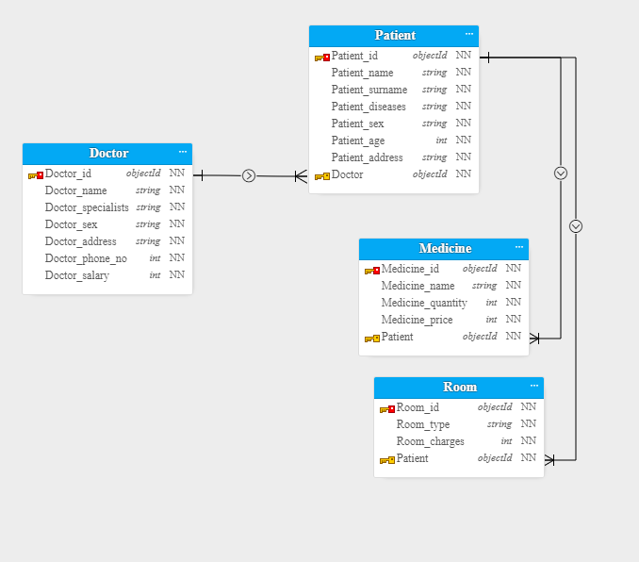

Doctors

create table doctor (doctor_id int, doctor_name varchar2(30),doctor_specialization varchar2(30),

doctor_sex varchar2(30),doctor_address varchar2(20),doctor_number int,doctor_salary int, Constraint doctor_id primary key (Doctor_id));

Patient

create table patient(patient_id int, patient_name varchar2(30),

patient_surname varchar2(30),patient_disease varchar2(30), patient_sex VARCHAR2(6),patient_age int,

patient_address varchar2(50), Doctor_id int,constraint patient_id_pk primary key(patient_id),

Constraint patient_doctor_fk foreign key(doctor_id)

REFERENCES Doctor(Doctor_id));

Medicine

create table Medicine(Medicine_id int , Medicine_name varchar2(20), Medicine_quantity varchar2(20),Medicine_price varchar2(20),patient_id int ,constraint Medicine_id_pk primary key(Medicine_id),

constraint Medicine_Patient_fk foreign key (Patient_id) references Patient(Patient_id));

Room

create table room(room_id int,room_type varchar2(20),room_charges int ,patient_id int ,constraint room_id_pk primary key(room_id),

constraint room_Patient_fk foreign key (Patient_id) references Patient(Patient_id));